Name: Cameron L'Ecuyer  
Class ID: 17  
Email: [cjlth5@mail.umkc.edu](mailto:cjlth5@mail.umkc.edu)  
Professor: Yugyung Lee  
[MyGitHub](https://github.com/camlecuyer/CS5551_11-1_LabAssignments)

Technical Partner: Name: Sneha Mishra  
Class ID: 21  
Email: [smccr@mail.umkc.edu](mailto:smccr@mail.umkc.edu)  
[GitHub](https://github.com/SnehaMishra28/CS5551_SnehaMishra_labassignments/wiki/CS5551_(11_1)_LabAssignment_lab%236)

[Ruthvic](https://github.com/Ruthvicp/CS5551_team_11-2_labassignments/wiki) is a member of team 11-2

[Semester Project GitHub](https://github.com/camlecuyer/CS5551_Team_11_Project)

**Objective**

Demonstrate part of our team's semester project, as the project is not yet fully complete. Deploying it to Heroku or AWS is not possible for our app, as it is an Android and Unity application

**Main Purpose of Project**

The main purpose of our project is to provide user's an augmented reality based assistant to help them visualize and select what furniture they would like before they go shopping for it and buy it

**Features**

* Android and Unity application
* Augmented Reality
* Login and Registration Pages with Firebase
* Image recognition
* API that searches for items online

**Steps for API Searching**

**First you must find an API that can search for products**

The API I eventually found that was free is called Indix. Originally the API was meant to search for clothes, but we changed the target of our application to furniture, and thankfully, Indix's API can search for furniture as well as clothing, as well as, other things  
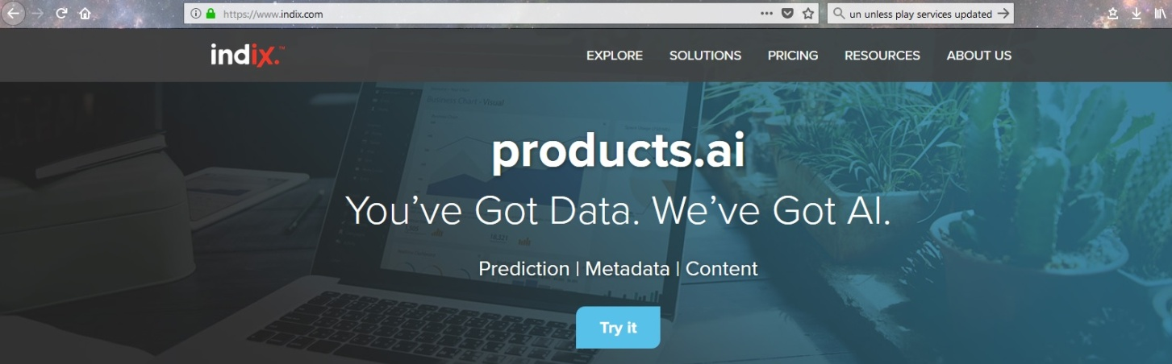

**Next you must find a way to allow Android to access REST services**

The tool I found was Google Volley 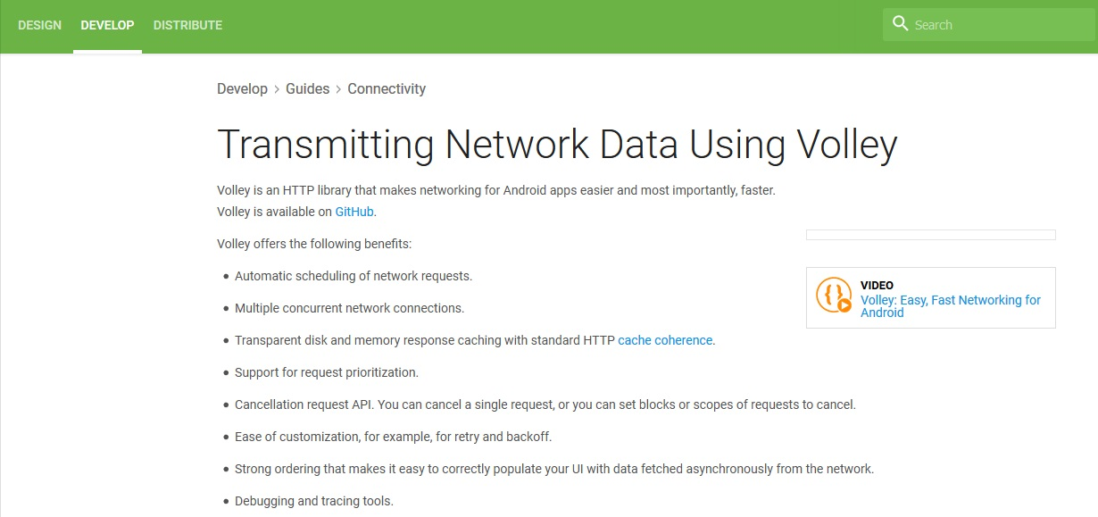

**After that you need to hook up the API and Volley in Android**

This image displays the code used to sort the list of items, while the one below it shows the code used to retrieve the data from the API, it makes use of Google's Volley framework  
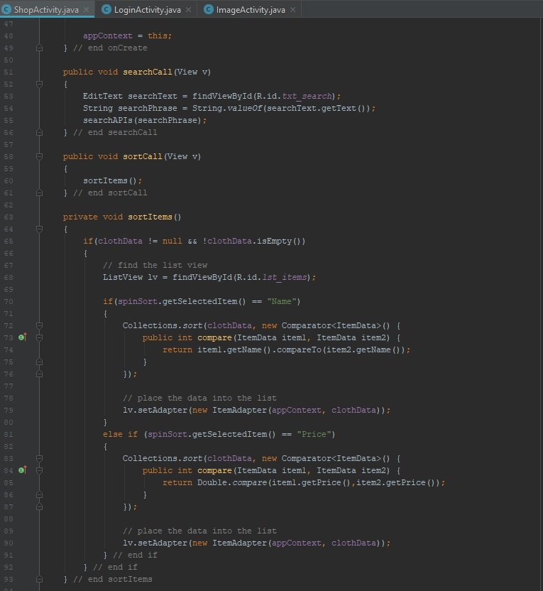

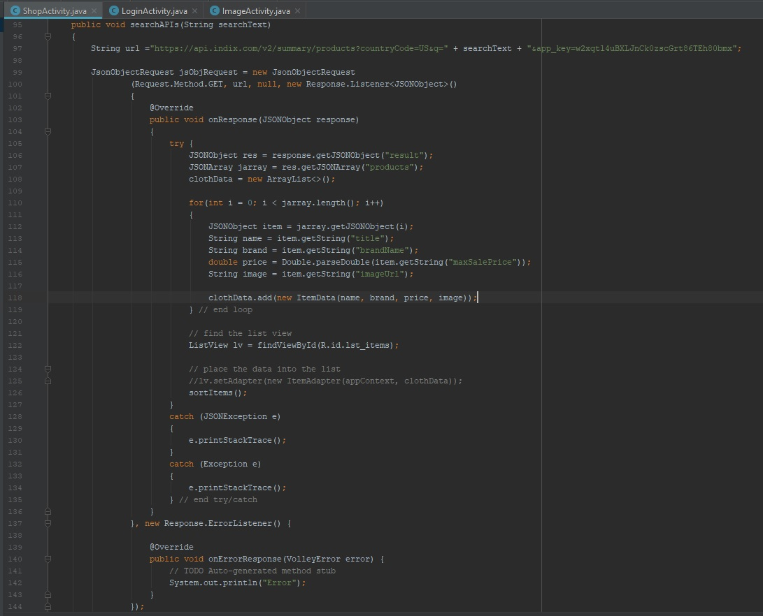

**Results**

This is the login page that takes a login from Twitter or from Firebase after registering, Sneha Mishra's Wiki displays more information about this page, and on the image recognition page, which is the image below it. Sneha also created a video showing the use of these pages: <https://www.youtube.com/watch?v=cuIv47Eokms>

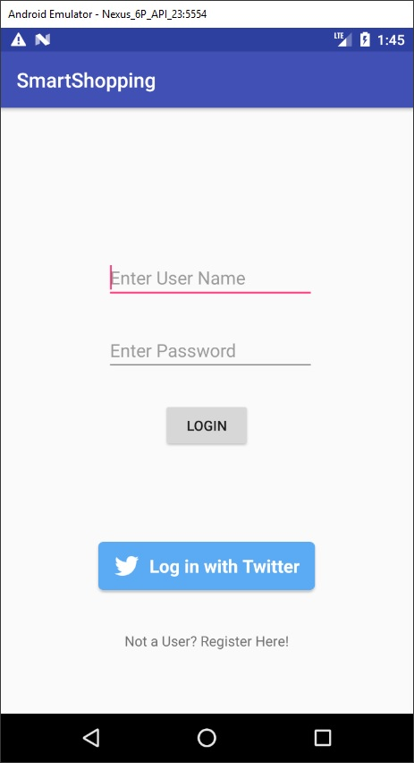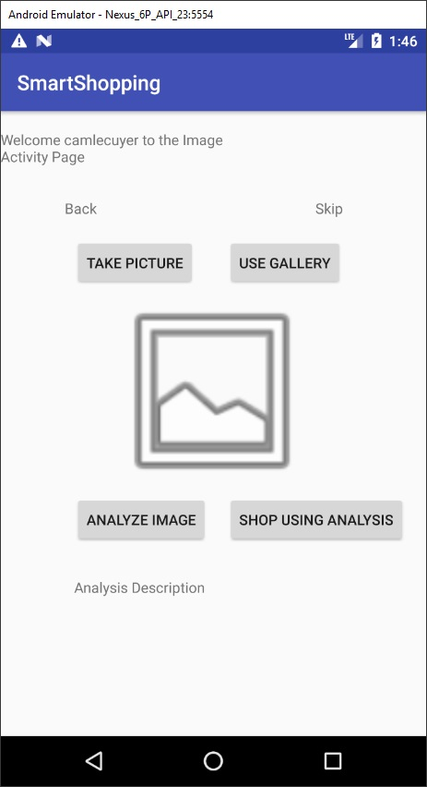

These images display the searching functionality of the app, which is one part that is still being used I am responsible for  
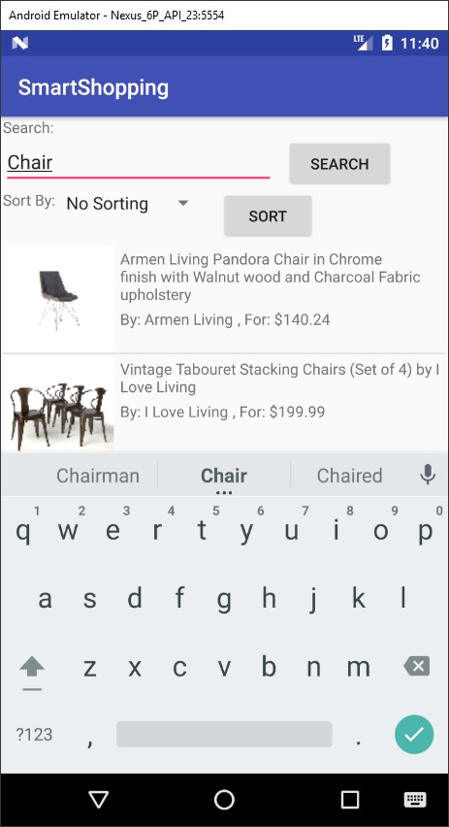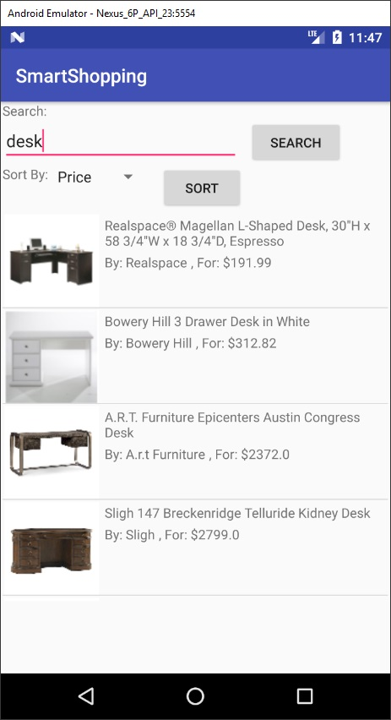

This image also displays what it looks like when one of the items is selected  
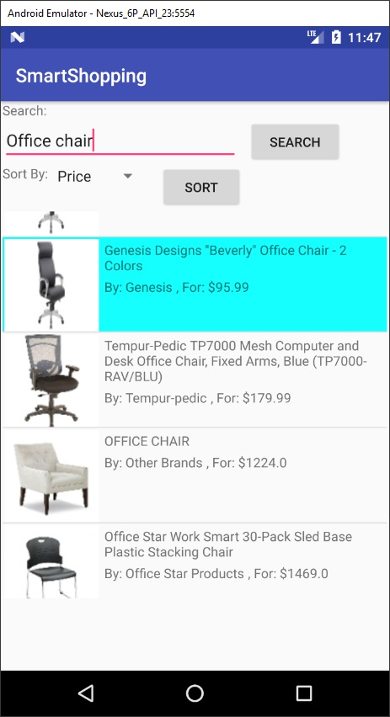

These images display the difference in sorting - either by price or by name  
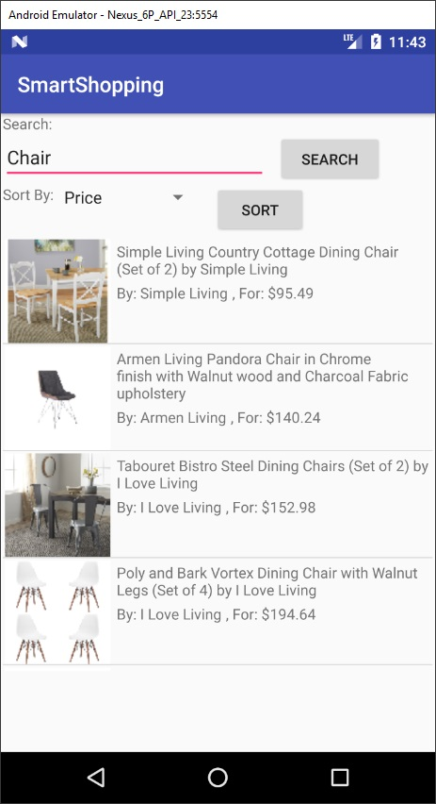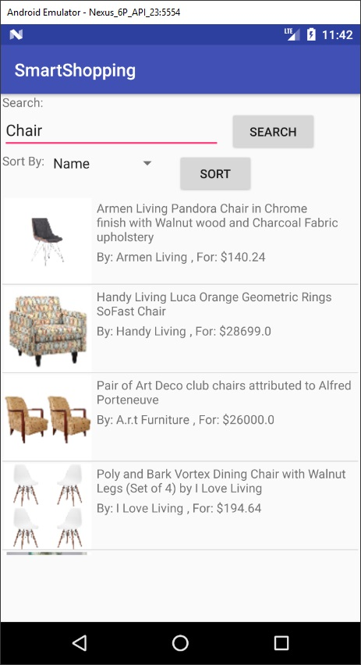

Ruthvic dealt with Unity and the Augmented Reality portion of the project

**References**

* Google Volley: <https://developer.android.com/training/volley/index.html>
* Indix Services: <https://www.indix.com/>